# APPENDICES

1. SOP 2.14 Roles and Responsibilities of FastTrack Personnel
2. FastTrack Model Flowchart
3. SOP 2.3: FastTrack Participant Recruitment and Enrolment
4. SOP 2.7: Dried Blood Spot (DBS) Collection and Handling
5. Viral Load Log Book

## **SOP 2.14: Roles and Responsibilities of FastTrack Personnel**

**PURPOSE**

This standard operating procedure (SOP) describes the key roles and responsibilities for all personnel in relation to FastTrack

**SCOPE**

This SOP applies to all personnel involved in the FastTrack model

**MATERIALS**

Patient Card

FastTrack Register Form

FastTrack Attendance Form

FastTrack Appointment Diary

**RESPONSIBILITIES**

* All personnel involved in FastTrack are responsible for adhering to their roles, implementing appropriate procedures, understanding and following this SOP, and following guidelines for the ethical conduct of healthcare service delivery at all times.
* **Pharmacy Technologist** is responsible for
  + Explaining the FastTrack model to the potential participant
  + Enrolling participants into FastTrack
  + Collecting dried blood spot specimens for viral load testing (with help from the lay HCW)
  + Dispensing drugs, entering data on the SmartCare pharmacy form, and accounting for drugs
* **Lay Health Care Worker** is responsible for symptom screening and brief adherence counseling, completing the FastTrack Attendance register, managing referrals to clinic, and referring missing patients to the clinic tracing team
* **Supervisor** is responsible for oversight of FastTrack staff
* **Data Associate** is responsible for entering participant data into Smartcare
* **The QA/QC Overseer i**s responsible for overseeing all quality control procedures related to this model

**PROCEDURES**

Lay Health Care Workers will:

* Review the FastTrack Appointment Diary to prepare files for patients a day before the visit
* Conduct symptom screening and brief adherence counseling using the FastTrack Attendance Register
* Assign the next FastTrack visit appointment (approximately 3 months from the day of the current visit) and indicate this day on the last column of the FastTrack Attendance Register. Also, write this date on the patient’s ART card.
* Escort/direct the patient to the pharmacy technologist to collect their drugs.
* Should need arise during the symptom screening, (patient ill or pregnant) the patients will be referred to the health facility for further management after they collect their drugs
* If a patient continues to require clinical visits at the health facility due to illness, he/she is still eligible to continue receiving drugs via FastTrack.
* In the event that the patient misses their FastTrack visit and does not show up within 5 days of their missed visit, the lay HCW should ensure that this individual be added to the clinic LTFU list so that they can be followed up based on standard of care at the clinic.
* Take the files for those who came through the FastTrack to the data room for data entry into Smartcare.
* After the data has been entered into Smartcare, take files to the registry for filing
* Ensure that the FastTrack member files are stored in separate file space in the registry

Pharmacy technologist will:

* Enroll all eligible clients into FastTrack
  + This includes explaining the FastTrack model to the client, and obtaining agreement from the client to participate
  + Collecting dry blood spot for viral load testing at enrollment and at 12 months post-enrolment (with help from the lay HCW)
* Will review the FastTrack Appointment Diary at least one day before the visit to prepare drugs in advance
* Provide drug adherence counselling
* Dispense drugs for three (3) months to the patient and enter the data onto the SmartCare pharmacy form
* Will also account for the drugs in accordance with MoH guidelines

FastTrack Member:

* Responsible for attending 2 clinical visits, 6 months apart
* Responsible for attending all FastTrack visits every 3 months
* In the event that a FastTrack member is unable to come to their FastTrack appointment, they should inform the Lay HCW so that arrangements for picking up their medication can be made

Data Associate:

* Responsible for entering all SmartCare forms for FastTrack patients into SmartCare once the files are brought back to the Data Room

## **3.0 FastTrack Flow Chart**

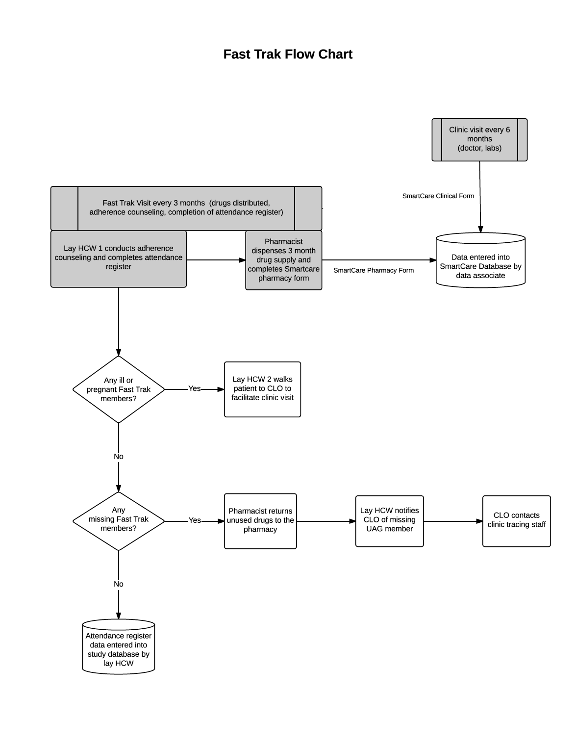

## **4.0 SOP 2.3: FastTrack Participant Recruitment and Enrolment**

**PURPOSE**

This standard operating procedure (SOP) describes the procedures for the recruitment and enrolment of participants into FastTrack.

**SCOPE**

This SOP applies to all personnel involved in the FastTrack model.

**MATERIALS**

FastTrack Enrolment Register

FastTrack Appointment Diary

FastTrack Infographic

**ROLES and RESPONSIBILITIES**

**Pharmacy Technologist** is rresponsible for:

* Conducting enrolment procedures
* Generating the initial FastTrack membership register including the clinic visit schedule

**Lay Health Care Worker** is responsible for:

* Assisting the Pharmacy Technologist with enrolment procedures

**QA/QC Overseer i**s responsible for:

* Overseeing all quality control procedures related to this model (please refer to SOP 3.5: Quality Assurance/Quality Control).

**PROCEDURES (See FastTrack Enrolment Flowchart)**

**1. Identification of individuals to approach for recruitment**

Patients attending the clinic for a visit with the doctor/ clinical officer will be approached for enrolment into FastTrack. During their clinical consultation, the clinician will review the patient’s chart to determine if they meet eligibility criteria for joining FastTrack.

Inclusion criteria:

* HIV-positive adolescents and adults (> 14 years of age)
* Last CD4 count (obtained within the last six months) > 200
* Not acutely ill
* On ART for at least 6 months

Exclusion criteria:

* Unwilling to participate in FastTrack
* Pregnancy

If eligibility criteria are met, then the doctor will direct the patient to the waiting lay HCW at the end of the clinical visit.

For patients that answer that they are unsure of their pregnancy status they will be offered the opportunity to take a pregnancy test by the clinician to further determine eligibility.

The lay HCW will briefly inform the patient that they have been invited to participate in a program that makes getting ARV’s easier for the patient. The lay HCW will escort the patient to the room where the Pharmacy Technologist is seated. The Pharmacy Technologist will then initiate a discussion about FastTrack using the Infographic.

**2. Describing the FastTrack Model**

The Pharm Tech will briefly describe the FastTrack model using the FastTrack Model Infographic. After going through the Infographic and answering any questions the patient will be asked if they are interested in joining FastTrack.

**3. Obtaining Dried Blood Spot Specimen for Viral Load testing**

Dried blood sample should be collected for viral load testing by the Pharmacy Technologist and/or the lay HCW. Please refer to SOP 2.7 for detailed procedures on collecting and handling the dried blood spot specimen.

**4. Generating the FastTrack Enrolment register**

As each patient is enrolled, add their information to the FastTrack enrolment register for that group.

Perform only once:

The very first time you fill out the FastTrack enrolment register, fill out the Clinic Name at the top of the form.

Perform each time you add a patient to the enrolment register:

1. The column “Enrolment number” should be numbered sequentially starting from 1. The first row should be 1, the second row should be 2, and so on. This will be helpful in M&E activities for tracking enrolment numbers over time.
2. List the ART ID and First Name, Sur Name.
3. In the next several columns, list the patients’: Sex, Date of Birth, Mobile phone 1, Mobile phone 2.
4. For “Date joined FastTrack”, write the date of FastTrack enrolment for that patient.
5. For “Date of first FastTrack Appointment”, write the date three months from the date of FastTrack enrolment for that patient.
6. Develop a schedule of all FastTrack member clinic visits to the facility. Clinic Visit 1 should be six months from the patient’s date of enrolment. Clinic Visit 2 should be six months after Clinic Visit 1.
7. Update the next appointment date in the clinical form in the patient’s ART file. The next clinical appointment date in the clinical form should be Clinic Visit 1.

**5. Completion of FastTrack Enrolment**

The patient’s new appointment dates should be written on their ART card and into the FastTrack Appointment Diary. The patient should proceed to the FastTrack pharmacist to receive a three-month drug supply. The pharmacist should place the date of the first FastTrack visit as the next pharmacy appointment date. The patient’s ART file should then be transferred to the data associate for entry into Smart Care.

## **5.0 FastTrack Enrolment Flow Chart**

## **8.0 SOP 2.7: Dried Blood Spot (DBS) Collection and Handling**

**PURPOSE**

This SOP outlines the procedures to be followed when Dried Blood Spot (DBS) samples from a finger prick are collected for viral load testing for HIV RNA. It also outlines the procedures to follow in case of a needle stick injury.

**PRINCIPLE**

A finger prick is done when collecting blood for Dried Blood Spots (DBS). DBS requires a lesser volume of blood with reduced infectious risk making it safer to handle than whole blood. It can also be stored and transported at room temperature (15-30 degrees).

**RESPONSIBILITIES**

All FastTrack staff are responsible for understanding and following this SOP.

**STAFF TRAINING REQUIREMENTS**

All staff that collect DBS specimens must have completed formal training before collecting DBS cards and have successfully completed a competence sheet.

**MATERIALS AND EQUIPMENT**

1. Lasec DBS Card
2. Gas impermeable storage bags
3. Desiccant packs
4. Humidity indicator (cards)
5. Alcohol swabs
6. Bandage/Plaster
7. Lancet
8. Drying racks
9. DBS lab requisition form
10. Gloves (always wash off the powder to avoid contaminating the specimens)
11. DBS transport and storage box

**PROCEDURES**

**1. Labeling the DBS card**

The DBS is collected on a Lasec DBS card. Prior to the specimen collection, the DBS cards and lab requisition forms are labeled with the patient’s information.

For FastTrack, we will use the patient ART number. Label the DBS card with the following:

1. Patient ART ID number
2. Site identification number
3. DBS preparation date/time

**2. Collecting specimen for DBS**

1. First, wash your hands before putting on gloves. If you wear powdered gloves, wash and dry your gloved hands to remove as much powder as possible.
2. Handle the DBS card carefully using the edges; NEVER touch the areas where the blood will be collected.
3. Use whole blood sample from finger prick.
4. Make sure to warm the participant’s hand and make sure the hand is below the level of the elbow (to allow gravity to help you collect the blood).

**NOTE:** When you do the finger prick sometimes blood comes out very slowly especially if it is cold or the person has thick skin. A lot of the time the instinct is to squeeze the finger WHICH IS WRONG, but a better way to do it is to make sure that the finger is pointing down (below the palm) and to squeeze the palm broadly instead.

1. Select finger for the procedure. Clean patient finger with disinfectant or alcohol wipe, generally middle or ring finger is preferred, avoid fingers with rings on.
2. Allow to air dry for 30 seconds.
3. Use a sterile, disposable lancet to puncture the skin to the side of the fingertip.
4. Dispose of the lancet in the biohazard container.
5. With the finger extended, wipe away the first drop of blood then allow a large, hanging drop of free flowing blood to accumulate at the puncture site.
6. To collect the drop of blood, touch the filter paper to the edge of the drop, allowing the blood to be drawn into the first circle on the card by capillary action. DO NOT allow the finger to touch the card.
7. Then, allow another large drop of free flowing blood to form at the puncture site and collect this drop in the **NEXT** circle.
8. You need only **ONE LARGE DROP PER CIRCLE.** Do not layer multiple drops of blood on top of each other.
9. Continue collecting drops of blood in the same manner until all the circles are filled on the DBS card (Fig 1. and 2.).

**Fig 1. Valid DBS cards**

All DBS must be collected on Lasec paper

Identifying information on the DBS card must match information on the lab requisition form

At least 3 spots 6mm in diameter or larger must be obtained

After drying, DBS should be dark and uniformly coloured



NAME*: JP 5040-133-0000-1*

DATE: *14/11/2014*

DOB: *01/10/2014*

Facility: *Kalingalinga - ALERE*

District: *Lusaka*

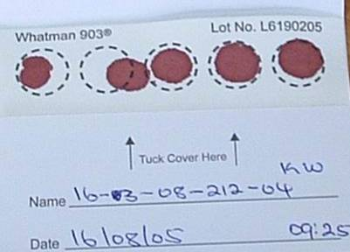

All 5 circles filled. At least 3 are valid.

**Fig2. Invalid DBS card**

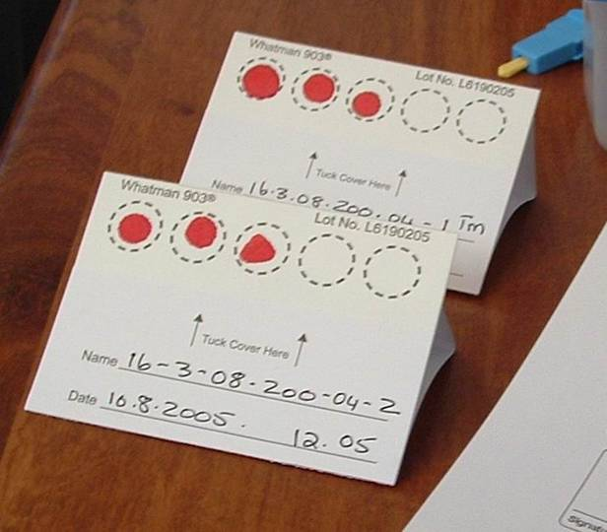

Blood spots are too small

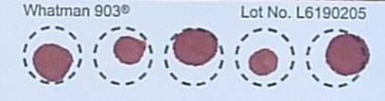

**4** Circles not filled

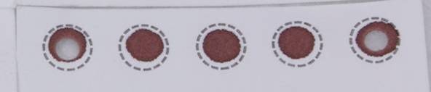

4.2**.** Blood has clotted

Specimen has clotted and appears layered

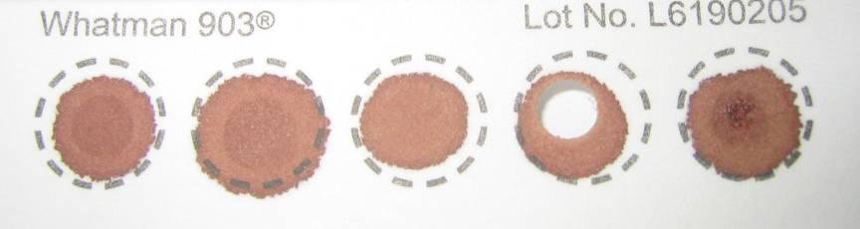

1. If the blood stops flowing before sufficient blood has been collected, gently massage the hand to encourage blood droplets formation. **DO NOT MILK THE FINGER** (i.e. do not squeeze or massage the finger area).

If necessary, a second finger can be cleaned and punctured using a new lancet to obtain adequate sample. It is important that adequate sample is collected; you must saturate each circle with blood.

1. If you are unable to obtain flowing blood using the finger stick despite multiple attempts, please inform the head nurse, clinician or in-charge.
2. After adequate sample is collected, give the participant gauze or swab to hold pressure to the fingertip. Elevate the fingertip above the elbow. After a matter of seconds or minutes, the bleeding should stop. No strapping, plaster, or band-aid is needed.

**3a. Handling specimen after collection in the CLINIC**

This section describes the procedure for handling a collected DBS specimen in the clinic.

1. After completing the sample collection, place the DBS card on the drying rack (Fig 3). The drying rack should ideally be placed so that the DBS cards dry in the horizontal position.
2. If no drying rack is available, the DBS card can be laid flat on a clean paper towel.
3. Fill out the clinic’s lab requisition form and leave it close to the DBS card, so it can accompany the card to the lab, once dry.

**Fig 3. DBS on drying rack**

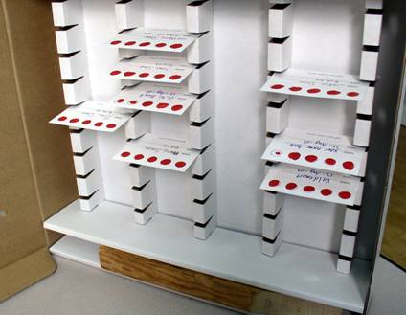

PRECAUTIONS WHEN DRYING THE DBS CARDS:

* Do not touch or smear the blood spots
* Keep away from direct sun-light, dust, and insects
* Do not heat, stack or allow DBS to touch anything during the drying process (including other DBS cards)

1. DBS cards must dry for at least 4 hours (though preferably overnight) prior to being placed in plastic bags and transported to the lab. **DO NOT USE AN EXTERNAL HEAT SOURCE TO DRY DBS.**
2. When dry, the spots will appear a uniform dark brown. The appearance should be similar to that of a dried bloodstain and no areas of red coloration should be seen.

**3b. Handling specimen after collection in the FIELD (outside of clinic) using a transport box**

This section describes the procedure for handling a collected DBS specimen in the field (outside of clinic).

1. Follow the procedure above for collecting DBS (2.1-2.16).

1. Allow the DBS card to dry sufficiently so blood is not flowing when placed in a transport box
2. Appropriately place the DBS card horizontally in a rack already provided in the transport box
3. The transport box must be carried horizontally at all times. **PROTECT YOUR DBS CARD FROM ANY DUST OR DIRECT SUNLIGHT AT ALL TIMES.**

1. When you return to the facility at the end of your tracing activities, ensure that each DBS card has had a lab requisition form filled out
2. When you arrive at the facility, remove the DBS card and leave to air dry effectively for 4 hours or till the next morning. If no drying rack is available at the facility, the DBS card can be laid flat on a clean paper towel.

1. Fill out the facility’s lab requisition form and leave it close to the DBS card, so it can accompany the card to the lab, once dry. Ensure the first two copies of the lab requisition accompany the DBS card to the lab. Retain the third copy and hand this to the person responsible for tracking lab requisition forms and samples to be sent to the reference laboratory.

**4. Packaging of DBS**

Packaging of the DBS is very important. DBS cannot be kept and/or transported at ambient temperature for longer than 14 days. If VL testing cannot be performed within 14 days from the date of collection, DBS should be transported to a central facility where there is a constant electricity supply and a -70°C freeze.

The manner in which they are packaged may determine the quality of the results in the future.

1. Once the DBS card is **COMPLETELY DRY**, place the card in a gas-impermeable zip-locked plastic bag with 1 desiccant pack.
2. Humidity causes damage to the HIV virus particles and should be avoided through use of desiccant and humidity cards.
3. The participant information should be visible through the bag. Make sure the humidity card is placed in the rear of the card facing out so that we can read the card and so that it does not obscure the view of the participant information on the card.
4. Keep the DBS card sealed in its bag from now to when it is ready to be tested. Gently apply pressure to the partially sealed bag to expel the air before sealing completely.
5. Bring the plastic bag containing the DBS along with the lab requisition form to the appropriate area in the clinic so that it can be transported to the national reference laboratory. **DO NOT STAPLE THE REQUISITION FORM TO THE PLASTIC BAG** as this will puncture the bag and allow air to enter.
6. Insert DBS bag into envelope. Place lab requisitions and specimen delivery checklist into envelope. Seal envelope. Label envelope clearly (“[insert Facility Name & Location] ART DBS specimens”). Send to testing lab at Kalingalinga.

_______________________________________________________________________

**PROCEDURES FOR NEEDLE STICK INJURY**

Purpose

The purpose of this section is to define procedures to follow when any staff member suffers a needle stick injury or blood contamination. This procedure applies to all staff involved in collection of blood specimens from Community ART participants.

Responsibilities

The staff members delegated to collect DBS specimens are responsible for understanding and following this section of the SOP.

The staff supervisor is responsible for ensuring that staff knows what action to take when one has a needle stick injury or is exposed to contaminated body fluids when handling and discarding used lancets, broken specimen containers or hazardous waste. In the event of a needle stick injury, it is important to receive all necessary medical attention as directed by the medical officer.

The staff supervisor has ultimate responsibility for ensuring that all applicable FastTrack staff members follow this SOP and that needle stick injuries are appropriately handled.

Appendices

Standard Operating Procedure: Management of Occupational Exposures to potentially Infectious Substances

**Procedures**

Clinic staff are to follow the following steps in case of needle stick injury and skin exposure while working with a patient with known HIV infection.

1. Immediately wash the site with soap and running water. Antiseptics such as alcohol or chlorhexidine can be used on small wounds and puncture sites – these agents have some virucidal activity. DO NOT USE BLEACH or other caustic agents to clean the exposure site or squeeze the wound.
2. In case of mucosal exposure, the exposed surface should be flushed with numerous amount of saline or water.
3. In case of exposure to the eye, immediately flush with copious amounts of clean water
4. Contact on site or nearby head nurse, clinician, In-Charge, or supervisor.
5. The individual with potential HIV exposure should present her/himself nearby health facility for immediate HIV counseling and testing. These results should be made available to health providers during discussions about post-exposure prophylaxis (see below). Should the HIV result be negative, the staff member should follow-up with a repeat test after 3 months.
6. The individual with potential HIV exposure should be referred to a service provider for post-exposure prophylaxis according to the organization’s medical policy (see Appendix).

## **14.0 Dried Blood Spot (DBS) Viral Load Log Book**

**Dried Blood Spot (DBS) Viral Load Log Book**

**Clinic Name:** _______________________________________________________

|  |  |  |  |  |
| --- | --- | --- | --- | --- |
| **Date of Specimen Collection**  **(DD/MM/YY)** | **Time of Specimen Collection**  **(HH:MM)** | **ART ID** | **Patient First Name** | **Patient Surname** |
|  |  |  |  |  |
|  |  |  |  |  |
|  |  |  |  |  |
|  |  |  |  |  |
|  |  |  |  |  |
|  |  |  |  |  |
|  |  |  |  |  |
|  |  |  |  |  |
|  |  |  |  |  |
|  |  |  |  |  |
|  |  |  |  |  |
|  |  |  |  |  |
|  |  |  |  |  |
|  |  |  |  |  |
|  |  |  |  |  |
|  |  |  |  |  |
|  |  |  |  |  |